APPENDIX A
PHOTOGRAPHS TAKEN DURING JIV AT 18” TEBIDABA-BRASS PIPELINE AT LAGOSGBENE COMMUNITY, SOUTHERN IJAW L.G.A, BAYELSA STATE ON 9TH MARCH, 2024.
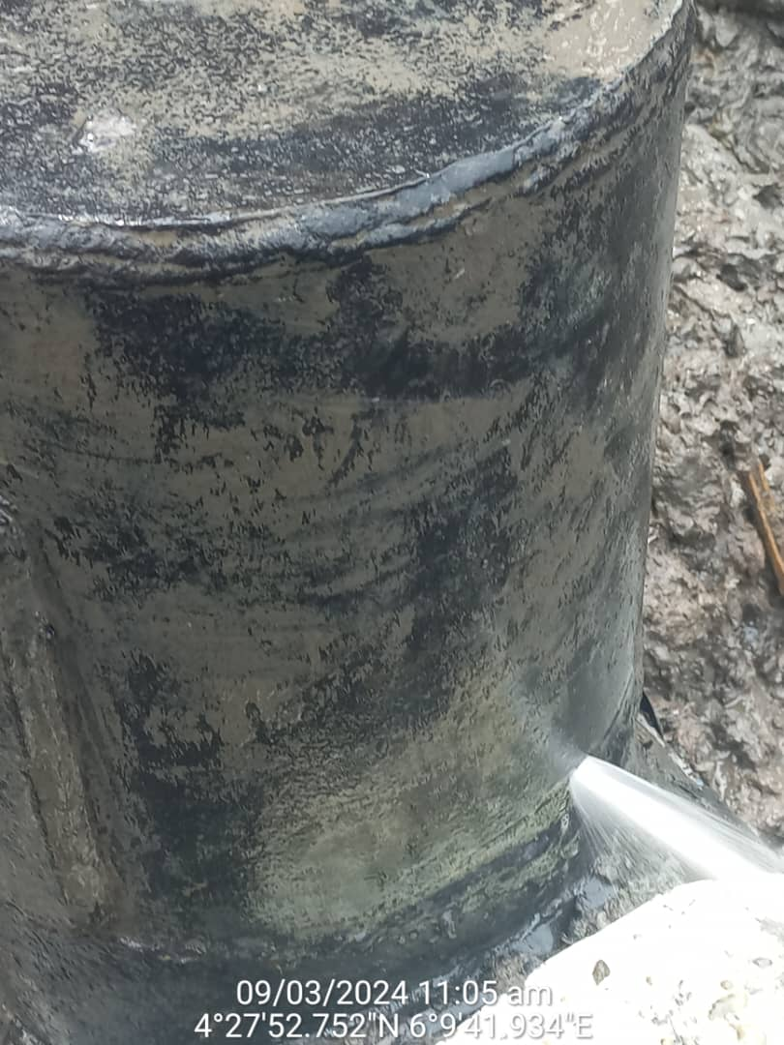
Fig. 1: Vandals used hacksaw to cut a section of previously repaired point at 12 o’ clock position of the pipeline.
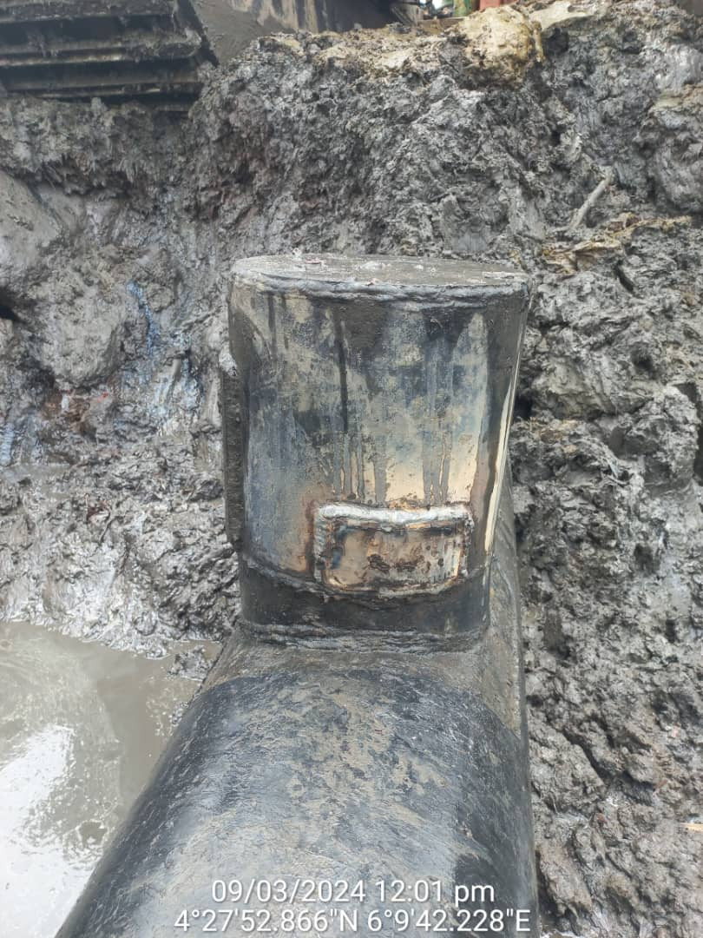
Fig. 2: The incident point after repair has been done.

